**Inheritance in C++**

The capability of a class to derive properties and characteristics from another class is called **Inheritance**. Inheritance is one of the most important feature of Object Oriented Programming. 

**Derived Class or Sub Class:** The class that inherits properties from another class is called Sub class or Derived Class.   
**Base Class or Super Class:** The class whose properties are inherited by sub class is called Base Class or Super class.

Advantage of C++ Inheritance

**Code reusability:** Now you can reuse the members of your parent class. So, there is no need to define the member again. So less code is required in the class.

Syntax of Inheritance

class parent_class

{

//Body of parent class

};

class child_class : access_modifier parent_class

{

//Body of child class

};

**Modes of Inheritance**

1. **Public mode**: If we derive a sub class from a public base class. Then the public member of the base class will become public in the derived class and protected members of the base class will become protected in derived class.
2. **Protected mode**: If we derive a sub class from a Protected base class. Then both public member and protected members of the base class will become protected in derived class.
3. **Private mode**: If we derive a sub class from a Private base class. Then both public member and protected members of the base class will become Private in derived class.

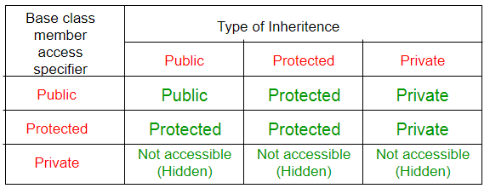

## Types Of Inheritance

**C++ supports five types of inheritance:**

1. Single level inheritance
2. Multilevel inheritance
3. Multiple inheritance
4. Hierarchical inheritance
5. Hybrid inheritance

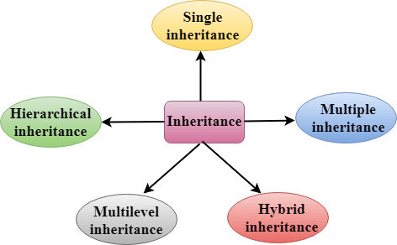

**Single Inheritance**:

When a single derived class inherit the properties of only single base class then such type of concept is known as single level inheritance

In single inheritance, a class is allowed to inherit from only one class. i.e. one sub class is inherited by one base class only.

**Single inheritance** is defined as the inheritance in which a derived class is inherited from the only one base class.

C++ Inheritance

Where 'A' is the base class, and 'B' is the derived class.

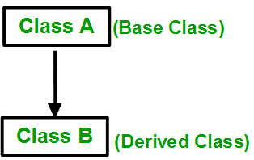

**Syntax:**

class **subclass_name** : access_mode **base_class**

{

//body of subclass

};

## Example no 1

#include <iostream>

class A

{

public: A( )

{

cout<<"I am in class A"<<endl;

}

};

class B: public A

{

public: B( )

{

cout<<"I am in class B";

}

};

void main()

{

//Creating object of class B

B obj;

getch();

}

Output

I am in class A

I am in class B

## Example no 2

#include<iostream.h>

#include<conio.h>

/* Exam no 2: single level inheritance */

class A

{

public: A()

{

cout<<"\n I am in class A";

}

};

class B : public A

{

public: B()

{

cout<<"\n I am in class B";

}

};

void main()

{

clrscr();

B b;

getch();

}

## Example no 3

#include<iostream.h>

#include<conio.h>

/* Exam no 3: single level inheritance */

class father

{

public: void show1()

{

cout<<"\n I have car";

}

};

class son : public father

{

public: void show2()

{

cout<<"\n I have cycle";

}

};

void main()

{

clrscr();

son s;

s.show1();

s.show2();

getch();

}